Interface RequirementS SPECIFICATION
(C3 - Video Proxy)

FOR

INTEGRATED VIDEO ANALYTICS HUB

Prepared by
NCS PTE LTD
© NCS PTE LTD. All rights reserved
No part of this publication may be reproduced, stored in a retrieval system, or transmitted in any form or by any means, electronic, mechanical, photocopying, recording or otherwise, for the purpose other than contract requirement, without prior written permission of NCS PTE LTD.

DOCUMENT INFORMATION
This document is agreed upon when signed by all parties. Amendments and modifications to this document must be mutually agreed upon and signed by each party in the attached amendment/change list.

By signing this document, all the following suppliers confirm that this document is sufficient for the proper design and fulfils the requirement on function and performance.

 | Name  Designation | Signature
NCS
Prepared by | Zuxian Cai  Pdt Engineer, Video Intelligence | Date: 31 Oct 2025
Reviewed by | Clarence Tan  Senior System Engineer, NCS  Liew Siek Siong  <title>, DSTA | Date: 31 Oct 2025
Approved by | David Yeo  Delivery Lead, Video Intelligence  Tan Yangzhi  SPgM (SAF IVH), DSTA | Date: 31 Oct 2025

REVISION HISTORY

Version | Effective Date | Summary of Changes | Author
1.1 | 24 Sep 2025 | Initial version. | Zuxian Cai
1.2 | 31 Oct 2025 | - Added API Get VA Event Image (5.2.13), Annotate Alert (5.2.16) and Apply Pushing VA Event Filter (5.2.17).  - Added mTLS preference in 2.1.  - Added successful HTTP Status Code 201 and 204 in 5.2.1.  - Changed common API path in 5.2.1.  - Added VA overlay support in Get camera snapshot API (5.2.14).  - Various improvements in APIs’ paths and definitions in 5.2.2 - 5.2.12, 5.2.14. | Zuxian Cai
1.3 | 25 Nov 2025 | - Freeze before workshop | Zuxian Cai
1.4 |  | - Updated seconds to milliseconds, for consistency:  - 5.2.6 (Get Camera Recording List)  - 5.2.9 Request Playback Video Stream (RTSP)  - 5.2.10 Request Playback Video Stream (WebRTC)  - 5.2.12 Query VA Events  - Delete response params channelId and streamId:  - 5.2.5 (Get Camera Recording Schedule  - Camera object capabilities added audio  Updated definitions for IVAH, WSS and removal of Video Proxy  Redefined Link Start-up procedure  5.2.4 Change Model name from Generate RTSP to General RTSP  5.2.16 Annotate alert’s isFalsePositive field is not mandatory

TABLE OF CONTENTS

1 Introduction 9
1.1 Purpose 9
1.2 Scope 9
1.3 Definitions, Acronyms and Abbreviations 9
1.4 References 9
2 Interface Requirements 10
2.1 Interface Configuration 10
2.2 Interface Identification 11
3 Interface Control Requirements 12
3.1 Link Start-Up Procedure 12
3.2 Link Failure Recovery Procedure 12
4 Data Control Requirements 13
4.1 Functional Requirements 14
4.1.1 Get Health Status of Video Proxy 14
4.1.2 Get Camera List 14
4.1.3 Live Stream (WebRTC) 14
4.1.4 Playback Stream (WebRTC) 14
4.1.5 Live Stream (RTSP) 15
4.1.6 Playback Stream (RTSP) 15
4.1.7 PTZ Control 16
4.1.8 Query VA Events 16
4.1.9 Push VA Events and System Health Status to C3 17
5 Message Requirements 17
5.1 Message Sequence 17
5.1.1 Link Start-up Message Sequence 17
5.1.2 RESTful API 17
5.1.3 Live Video Streaming (WebRTC) Request Flow 18
5.1.4 Playback (WebRTC) Request Flow 19
5.1.5 Live Video Streaming (RTSP) Request Flow 21
5.1.6 Playback (RTSP) Request Flow 22
5.1.7 Pushing VA Events and System Health Status 23
5.2 Message Definitions 23
5.2.1 Common Definitions 23
5.2.2 Get Health Status of Video Proxy 26
5.2.3 Get Stream License Usage 27
5.2.4 Get Camera List 28
5.2.5 Get Camera Recording Schedule 32
5.2.6 Get Camera Recording List 34
5.2.7 Request Live Video Stream (RTSP) 37
5.2.8 Request Live Video Stream (WebRTC) 38
5.2.9 Request Playback Video Stream (RTSP) 41
5.2.10 Request Playback Video Stream (WebRTC) 43
5.2.11 PTZ Control 46
5.2.12 Query VA Events 47
5.2.13 Get VA Event Image 53
5.2.14 Get Camera Snapshot 55
5.2.15 Generate Event Video 57
5.2.16 Annotate Alert 58
5.2.17 Apply Pushing VA Event Filter 60
5.2.18 System Health Status 63
5.2.19 Customization on RTSP 66
5.2.19.1 RTSP VA Event Filtering Command 66
5.2.19.2 RTSP Playback Command 67
5.2.19.3 RTSP Channels 68
5.2.19.4 Error Code In RTSP 69
5.2.19.5 UTC Timestamp in the RTP Header 71
5.2.20 WebRTC Data Messages 72
5.2.20.1 Play 72
5.2.20.2 Pause 73
5.2.20.3 KeepAlive 73
5.2.20.4 Response 73
5.2.20.5 VA Event Message 74
5.2.20.6 Error Message 74

TABLE OF FIGURES

Figure 1 Connection between C3 and Video Proxy 10
Figure 2 Flow of RESTful API Calls 18
Figure 3 Flow for Video Live Stream 19
Figure 4 Flow for Playback Request 21
Figure 5 Flow for RTSP Live-View Request 22
Figure 6 Flow for RTSP Playback Request 23
Figure 7 SDP Sample 69

LIST OF TABLES
Table 1 Definitions, Acronyms and Abbreviations 9
Table 2 References 10
Table 3 Number Data Types 24
Table 4 Failure Response Body 26
Table 5 RESTful API Response Error Code 26
Table 6 RTSP Error Code 70
Table 7 WebRTC Error Code 75

Introduction

Purpose
The purpose of this Interface Requirement Specification (IRS) is to specify the key functional requirements of the interface between C3 System and Video Proxy.

Scope
There are requirements for Video Proxy to provide the onboard Devices resource to the C3 System. The resource includes device base information, device stream for live view and playback, control of the device and Video Proxy status.
- C3 to Video Proxy interface

Definitions, Acronyms and Abbreviations
AFE | Authority Furnished Equipment
C3 | Command, Control & Communication
CA | Certificate Authority
ICE | Interactive Connectivity Establishment
IVAH | Integrated Video Analytics Hub
DTLS | Datagram Transport Layer Security
IP | Internet Protocol
JSON | JavaScript Object Notation
MMI | Man-Machine Interface
MMQT | Message Queuing Telemetry Transport
RTP | Real-Time Transport Protocol
RTSP | Real-Time Streaming Protocol
SDP | Session Description Protocol
WSS | WebSocket Secure
Table 1 Definitions, Acronyms and Abbreviations

References
Reference No/Document | Doc. No.
Data and time format | ISO 8601
DTLS | RFC 5764
ICE | RFC 8445
RTP | RFC 3550, 4585, 6184
RTSP | RFC 2326
SDP | RFC 4566
URI | RFC 3986
URL | RFC 1738
VA Event IRS | 1.0
WebRTC | RFC 8445, 8829, 8831
Table 2 References

Interface Requirements

Interface Configuration
Figure 1 Shows the connection between C3 and Video Proxy.
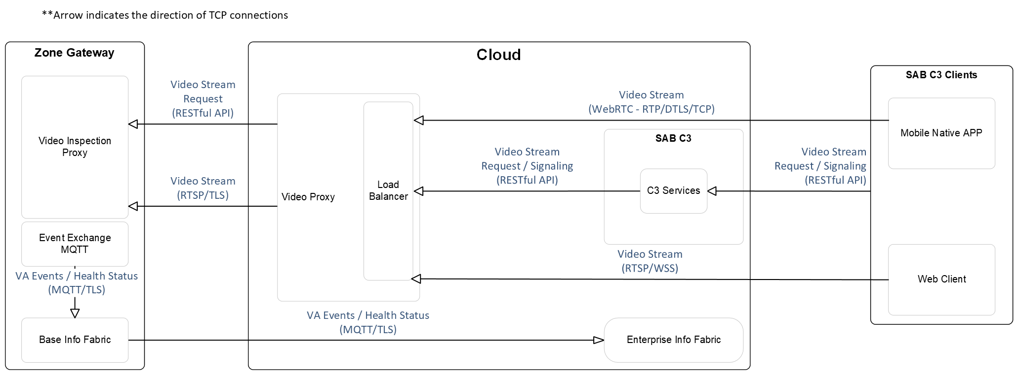
Figure 1 Connection between C3 and Video Proxy

RESTful API (HTTPS)
- C3 will call the RESTful API of Video Proxy.
- This will allow C3 to get data from Video Proxy, manage video stream sessions, as well as exchange their SDP and establish connections through the ICE candidates indicated inside the SDP.
- mTLS is preferred.

Video Stream (WebRTC - RTP/DTLS/TCP)
- C3 mobile native APP pulls video streams from Video Proxy through WebRTC.
- After establishing a connection between C3 mobile native APP and Video Proxy, Video Proxy will stream the video through the connection.
- mTLS is preferred.

Video Stream (RTSP/WSS)
- C3 web client pulls video streams from Video Proxy through RTSP over WSS.
- After establishing a connection between C3 web client and Video Proxy, Video Proxy will stream the video through the connection.
- mTLS is preferred.

VA Events (MQTT/TLS)
- Video Proxy will send C3 VA events and health status after establishing a successful connection.
- mTLS is preferred.

Interface Identification
The links between C3 and the Video Proxy are:
- Video Proxy-Zone Gateway Network.
- AFE Cloud Network.

C3 to Video Proxy interface
- A digital full duplex channel via AFE Network.

Video Proxy communicates:
- Via TCP with C3 services, Info Fabric, web client and mobile native APP.

Interface Control Requirements

Link Start-Up Procedure
- Regarding the link for RESTful API:

- To determine Video Proxy’s availability, C3 is expected to call Video Proxy’s Health API (refer to 5.2.2) every 30 seconds.
- If C3 receives an error response from the Health API, C3 should not call any of Video Proxy’s other APIs until the next scheduled Health API call returns a successful response.
This health check is independent from all other API calls to Video Proxy.

- Regarding the link for video streaming:
- For video streaming, when C3 Web Client successfully setup RTSP connection and can get GET_PARAMETER response in 4 seconds, the link of the video streaming is considered established.
- For video streaming, when C3 Mobile Native APP successfully setup WebRTC connection and can get KEEP_ALIVE response in 4 seconds in data channel, the link of the video streaming is considered established.

- Regarding the link for messaging on VA event and health status:
- Once Video Proxy connected to C3’s Info Fabric via MQTT protocol, the link for messaging is considered established.

Link Failure Recovery Procedure
- Regarding link failure for RESTful API:
- In the following situations the link is considered failure:
  - No response to the Health API call from Video Proxy.
  - Error response to the Health API call from Video Proxy.
  - Unhealthy status in the response to the Health API call from Video Proxy.
- Recovery:
  - Once getting a successful response with healthy statuses from Video Proxy again.

- Regarding link failure for video streaming via WebRTC:
- In the following situations the link is considered failure:
  - TCP connection is lost.
  - No KEEP_ALIVE response in 4 seconds
  - Receiving Error Code, 400,454, Refer to 5.2.17.6.
- Recovery:
  - A Mobile Client reconnection is required.

- Regarding link failure for video streaming via RTSP:
- In the following situations the link is considered failure:
  - TCP connection is lost.
  - No GET_PARAMETER response in 4 seconds
  - Receiving Error Code, 400,454, Refer to 5.2.16.4
- Recovery:
  - A Web Client reconnection is required.

- Regarding link failure for message channel:
- In the following situations the link is considered failure:
  - TCP connection is disconnected.
  - MQTT connection error occurred.
- Recovery:
  - MQTT connection is back to normal.

Data Control Requirements
This section covers the data exchange requirements for the interface of C3 and Video Proxy.

Functional Requirements

Get Health Status of Video Proxy
- Periodically, C3 calls Video Proxy’s health API to check:
- Availability of Video Proxy

Get Camera List
- C3 gets the list of cameras from Video Proxy.
- The recording schedule created for a camera can be queried and C3 could use it to check whether the camera has recording ongoing.

Live Stream (WebRTC)
- C3 should specify one camera in the RESTful API call when requesting live stream. Video Proxy will verify the device’s existence, then reply with the SDP.

- With the SDP from Video Proxy, C3 should establish the WebRTC connection to Video Proxy and exchange ICE candidates.

- After successfully exchange info through WebRTC, C3 will receive RTP packets through the same TCP connection.

Playback Stream (WebRTC)
- Before requesting playback, C3 may query recording availability by calling the recording list API.
- C3 should specify one camera and playback period in the RESTful API call when requesting playback stream. Video Proxy will verify the camera’s existence and recording availability, then reply with the SDP.

- With the SDP from Video Proxy, C3 should establish the WebRTC connection to Video Proxy and exchange ICE candidates.

- After successfully exchange info through WebRTC, C3 will receive RTP packets through the same TCP connection.

- While streaming, C3 may send playback commands such as “Play”, “Forward Seeking”, “Backward Seeking”, “Fast Forward”, “Slow Motion” to Video Proxy through WebRTC’s data channel. Upon failure, C3 will receive a failure message through data channel.

Live Stream (RTSP)
- C3 should specify one camera in the RESTful API call when requesting live stream. Video Proxy will verify the device’s existence, then reply with the RTSP URL.

- With the URL from Video Proxy, C3 should establish the RTSP connection to Video Proxy and start the RTSP session.

- After successfully exchange info through RTSP, C3 will receive RTP packets through the same TCP connection.

Playback Stream (RTSP)
- Before requesting playback, C3 may query recording availability by calling the Camera Recording List API.
- C3 should specify the camera and playback period in the RESTful API call when requesting Playback stream from a camera. Video Proxy will verify the device’s existence and recording availability, then reply with the RTSP URL.

- With the URL from Video Proxy, C3 should establish the RTSP connection to Video Proxy and start the RTSP session.

- After successfully exchange info through RTSP, C3 will receive RTP packets through the same TCP connection.

- While streaming, C3 may send playback commands such as “Play”, “Forward Seeking”, “Backward Seeking”, “Fast Forward”, “Slow Motion” to Video Proxy through RTSP commands. Upon failure, C3 will receive a failure message through RTSP.

PTZ Control
- C3 should specify the device and action in the RESTful API call when requesting PTZ action to a camera.

- After receiving the request, Video Proxy will forward this request to IVAH.

- If device does not exist or action requested failed, C3 will receive a failure response.

Query VA Events
- C3 could query VA events by various filters:
- The events’ VA Event Type.
- Event’s generated datetime.
- The camera which the VA instance is running on.
- The order of the result data, which supports: Descend (desc) or Ascend (asc)

- C3 could download the VA image chip with the image ID from the VA event.

- C3 could download the full-frame snapshot of the camera on the time of the VA event, as long as camera has a recording scheduled within the queried event date time. The snapshot does not contain bounding box data by default, but a VA APP can be indicated to overlay the bounding box or other information from VA.

Push VA Events and System Health Status to C3
- Video Proxy pushes VA events to Base Info Fabric in near real time.
- C3 could filter the VA events to be received from IVAH by indicating VA APPs and/or event types:
- Zone Gateway every 5 minutes pushes the system health status to Base Info Fabric, including:
- Kubernetes nodes: CPU, GPU, Memory and disk usage.
- System level status: VMS, MMI, VAP
- Camera Status

Message Requirements

Message Sequence

Link Start-up Message Sequence
- C3 calls the Health API (refer to 5.2.2) to Video Proxy.

- Upon successful response from Video Proxy, the link is considered established between Video Proxy and C3, otherwise the link is considered a failure.

RESTful API
- The following functions are served through RESTful APIs:
- Get health status of Video Proxy (refer to 5.2.2).
- Get the camera list (refer to 5.2.4).
- Get the camera schedule (refer to 5.2.5).
- Get the camera recording list (refer to 5.2.6).
- PTZ control (refer to 5.2.11).
- Query VA events (refer to 5.2.12).
- Get VA event image (refer to 5.2.13).
- Get VA event snapshot (refer to 5.2.14).
- Generate event video (refer to 5.2.15).
- Annotate alert (refer to 5.2.16).
- Apply VA event pushing filter (refer to 5.2.17)

- The diagram below shows the RESTful APIs communication between C3 and Video Proxy.
Step1: C3 sends API request to Video Proxy.
Step 2: Video Proxy verifies and validates the request.
Step 3a/3b: Video Proxy responds either error or successful response to C3.
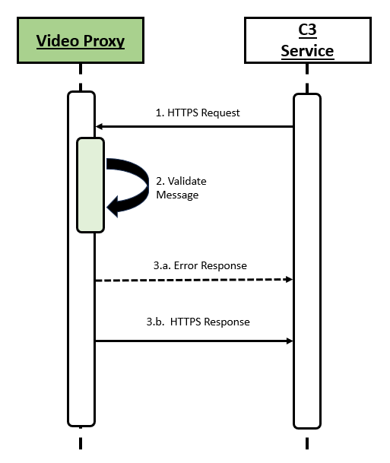
Figure 2 Flow of RESTful API Calls

Live Video Streaming (WebRTC) Request Flow
- The diagram below shows communication between the Client and Video Proxy to request and receive the live-stream URL from a video device.
- The Client starts by creating a WebRTC peer connection and generating an SDP offer. This offer contains information about the types of media it can receive. The offer is sent to C3, which forwards it to Video Proxy.
- Video Proxy receives the offer and sets up its own peer connection. It processes the SDP offer, gathers its own network connection options (ICE candidates), and creates an SDP answer in response.
- Video Proxy then sends the SDP answer along with its ICE candidates back to C3, which relays them to the Client.
- Once Client receives this response, both Client and Video Proxy exchange any additional ICE candidates if needed and attempt to find the best network path between them.
- When the connection is successfully established, media streaming can begin directly between the Client and Video Proxy.
Figure 3 Flow for Video Live Stream

Playback (WebRTC) Request Flow
- The diagram below shows how a connection is established between the Client and Video Proxy in order to Playback from a Video Device.
- The Client starts by creating a WebRTC peer connection and generating an SDP offer. This offer contains information about the types of media it can receive. The offer is sent to C3, which forwards it to Video Proxy.
- Video Proxy receives the offer and sets up its own peer connection. It processes the SDP offer, gathers its own network connection options (ICE candidates), and creates an SDP answer in response.
- Video Proxy then sends the SDP answer along with its ICE candidates back to C3, which relays them to the Client.
- Once Client receives this response, both Client and Video Proxy exchange any additional ICE candidates if needed and attempt to find the best network path between them.
- When the connection is successfully established, the Client can start sending playback commands through the data channel.
Figure 4 Flow for Playback Request

Live Video Streaming (RTSP) Request Flow
- The diagram below shows communication between the C3 RTSP Client and Video Proxy to request and receive the live-stream URL from a video device
- C3 should specify the device in the RESTful API call when requesting RTSP Live stream from a camera.
- If device does not exist or connection is unable to established, C3 will receive a failure message and requires calling the RESTful API again to retry the request.
- After verifying that the device exists and supports live view, C3 will receive an RTSP URL. C3 should connect to this URL and perform an RTSP handshake with the Video Proxy. Upon successful connection, the media stream will be delivered in RTP over RTSP format.
- If the RTSP handshake fails or the camera encounters an error while pushing the stream, the server will return an error code. Based on the specific error code, C3 should either re-initiate the live view request or retry the RTSP handshake using the existing URL.
Figure 5 Flow for RTSP Live-View Request

Playback (RTSP) Request Flow
- The diagram below shows communication between the C3 RTSP Client and Video Proxy to request and receive the playback-stream URL from a video device
- C3 can seek and change play speed via RTSP PLAY requests, and playback can be paused using RTSP PAUSE requests

Figure 6 Flow for RTSP Playback Request

Pushing VA Events and System Health Status
- Event Exchange MQTT Service pushes VA events to Base Info Fabric via MQTT over TLS 1.3.
- Authentication between IVAH and Info Fabric will be mTLS (TBC).
- Event Exchange MQTT Service periodically sends system health status to Base Info Fabric, including:
- Kubernetes nodes: CPU, GPU, Memory and disk usage.
- Services: The number of replicas and the status.
- VA Events are in JSON format.

Message Definitions

Common Definitions
This section describes the common definitions applicable to all APIs requested from C3 to Video Proxy. Request and response bodies are in JSON format unless otherwise stated.

- Number Data Types
Type | Lower Bound Value | Upper Bound Value
Int8 | MIN_INT8 = -128 | MAX_INT8 = 127
Uint8 | 0 | MAX_UINT8 = 255
Int16 | MIN_INT16 = -32768 | MAX_INT16 = 32767
Uint16 | 0 | MAX_UINT16 = 65535
Int32 | MIN_INT32 = - 2^31 | MAX_INT32 = 2^31 - 1
Uint32 | 0 | MAX_UINT32 = 2^32 - 1
Int64 | MIN_INT64 = - 2^63 | MAX_INT64 = 2^63 - 1
Float* | MIN_FLOAT = -3.4028235e38 | MAX_FLOAT = 3.4028235e38
Double* | MIN_DOUBLE =  -1.7976931348623157e308 | MAX_DOUBLE =  1.7976931348623157e308
Table 3 Number Data Types
* e stands for 10’s exponent.

- Request
- URL: https://{ivah-domain}:{port}/nbapi/v1/{path}. In the API definitions, only the path of the request will be stated.
- Header:
Field  Name | Data  Type | Mandatory | Allowed values | Description
Content-Type | String(16) | Yes | application/json
Transaction-Id | String(36) | Yes | Character set:  - a-z  - 0-9  - - | Unique request ID, usually using UUID.  Example: 0ee1b9d1-24b7-4f55-8539-87f750bc5ad4
Authorization | String(43) | Yes | “Apikey {apikey}”  Character set of apikey:  - a-z  - A-Z  - 0-9  - - | IVAH issued unique key for the C3 System to call APIs.  Example:  Apikey b5fcf9fb-71d3-466d-8313-be62ISMSb5a4f9

- Response:
- Header:
Field  Name | Data  Type | Allowed values | Description
Transaction-Id | String(36) | Character set:  - a-z  - 0-9  - - | Unique request ID, usually using UUID.  Example: 0ee1b9d1-24b7-4f55-8539-87f750bc5ad4

- Successful response HTTP Status Code: 200, 201, 204
- Failure response:
  - HTTP Status Code:
    - 400: Bad Request
    - 401: Unauthorized
    - 403: Permission Denied
    - 404: Not Found
  - Body: Failure response
Field  Name | Data  Type | Allowed Values | Description
code | String(30) | Character set:  - a-z  - A-Z  - 0-9  - - | Error code, please refer to the specific API  E.g:  “device-not-found”
params | Array of String | Character set of array elements: Any | Multiple string values allow for variation of data to be displayed passed to frontend  E.g:  [“500”]
Table 4 Failure Response Body

Failure Response body sample:
{
“code”: “exceeded-stream-limit”,
“params”: [“500”]
}

Error code in the body varies across the APIs, but with some HTTP status code the error code is common. The HTTP status code and related error code are:

HTTP Status Code | Error Code | Description
400 | bad-request | Bad request.  This is the error code for 400 applies to all APIs, although individual APIs may add more error codes for 400.
401 | unauthorized | Unauthorized.  It will be always this error code for 401.
403 | forbidden | Forbidden.  It will be always this error code for 403.
Table 5 RESTful API Response Error Code

Get Health Status of Video Proxy
- This message is sent when C3 requests health status update.

- Request:
- Method: GET
- Path: health-status
- Response:
- Successful:
  - HTTP Status Code: 200.
  - Body:
Field  Name | Data  Type | Allowed Values | Description
moduleName | String(20) | VIDEOPROXY | Video Proxy returns default value.
moduleStatus | String(1) | A  I | Video Proxy application status,  One of the following values, Video Proxy returns the code to external:  • A - Active  • I - Inactive
timestamp | Int64 | 0 – MAX_INT64 | Timestamp of latest health check.  Epoch Time in milliseconds.  E.g：  1749626843000

- Failure:
  - HTTP Status Code: 400, 401, 403.
  - Response body defined in Table 4.
  - Error code defined in Table 5.

Get Stream License Usage
- This message is sent when C3 requests for the latest Stream License status.

- Request:
- Method: GET
- Path: sensor/streams/usage
- Response:
- Successful:
  - HTTP Status Code: 200.
  - Body:
[ | Data  Type | Allowed Values | Description
totalStreamLicense | Uint16 | 0 - 32767 | Total concurrent stream license assigned to the C3 System
licenseInUse | Uint16 | 0 - 32767 | Total stream license in use.
timestamp | Int64 | 0 - MAX_INT64 | Time to validate the Video Proxy status.  Epoch Time in milliseconds.  E.g：  1749626843000
- Failure:
  - HTTP Status Code: 400, 401, 403.
  - Response body defined in Table 4.
  - Error code defined in Table 5.

Get Camera List
- This message is sent when C3 requests for the list of devices.
- Request:
- Method: POST
- Path: sensor/channels/search
- Body:
Field  Name | Data  Type | Mandatory | Allowed values | Description
deviceName | String(512) | No | Any | Filter result with Device’s Name.  Fuzzy query & Case-insensitive.  E.g: deviceName001
channelName | String(512) | No | Any | Filter result with Channel’s Name.  Fuzzy query & Case-insensitive.  E.g: channelName001
modelId | String(30) | No | • digifort  • milestone | Filter result with Device’s Model ID
status | String(15) | No | • online  • offline  • disconnected | Device status in the system
channelStatus | String(15) | No | • online  • offline  • disconnected | Channel status in the system
pageIndex | Int64 | Yes | 1 – MAX_INT64 | The Page Index, start from 1
pageSize | Uint16 | Yes | 1 - 999 | Return record per page, allow max to 999.

- Response:
- Successful:
  - HTTP Status Code: 200
  - Body:
Field  Name | Data  Type | Allowed Values | Description
pageIndex | Int64 | 1 – MAX_INT64 | The request page index.
pageSize | Uint16 | 1 - 999 | Return record per page, allow max to 999.
totalNum | Int64 | 1 - MAX_INT64 | Total number of cameras in the result set.
totalPages | Int64 | 1 - MAX_INT64 | Total pages for the devices
data | Array of Camera Object |  | Refer to the Camera object details

Camera Object definitions:

Field  Name | Data  Type | Allowed Values | Description
capabilities | String(100) | Comma separated string with allowed items:  - live  - playback  - ptz  - ptz-preset | Device’s Capabilities;  Combine of them.  E.g:  live  live,playback  live,ptz
deviceId | String(32) | Character set:  - a-z  - 0-9 | Device ID in the system, a UUID  E.g: 52d86f9b83a1ac82743ae642fe4cb800
deviceName | String(512) | Any | Device Name.  E.g: deviceName001
channelId | String(32) | Character set:  - a-z  - 0-9 | Channel ID, a UUID  E.g: 52d86f9b83a1ac82743ae642fe4cb800
channelName | String(512) | Any | Channel Name.  E.g: channelName001
modelId | String(30) | • digifort  • milestone-onb | Filter result with Device’s Model ID
modelName | String(30) | Character set:  - a-z  - A-Z  - 0-9  - -  - <space> | Device’s Model Name.  E.g: General RTSP, Onvif IPC
scheduleName | String(255) | Character set:  - a-z  - A-Z  - 0-9  - - | Device’s Schedule plan in MMI  E.g: "default724", "recordWhenStream"
scheduleId | String(36) | Character set:  - a-z  - 0-9  - - | Device’s Schedule ID  E.g: 3ab3973f-e36c-4105-9ca3-f297fba8b714
streamInfos | Array of StreamInfo Object |  | Camera’s all resolution Options. Refer to the StreamInfo object definition.  The number streams of a camera is usually 1 to 3, but it’s also possible for some cameras to have more than 3 streams.
status | String(15) | One of the following fixed status value:  • online  • offline  • disconnected | Device status in the system

StreamInfo Object Definition:
Field Name | Type | Allowed values | Description
codec | String(5) | • H264  • H265 | Stream codec.
streamId | Uint32 | 0 - MAX_UINT32 | Index of stream in a camera. Streams usually differ in resolution, bitrate etc.
fps | Uint16 | 0 - MAX_UINT16 | Camera fps, E.g 24 fps
name | String(64) |  | Name of the Camera Resolution options  E.g:  Main, sub, third …
bitrate | Float |  | Bitrate of the Stream (Kbps)  E.g:  4096.0, 1024.0 …
resolution | String(16) |  | Camera’s supporting Resolution  E.g:  “1920x1080”, “1280x720”, “720x576” …
status | String(10) | - ok  - disconnected | Stream status  E.g:  “ok”, “disconnected”

- Failure:
  - HTTP Status Code: 400, 401, 403.
  - Response body defined in Table 4.
  - Besides error codes defined in Table 5, below are the specific error codes:
HTTP Status Code | Error Code | Params | Description
400 | invalid-page-index |  | ‘pageIndex’ is invalid
400 | invalid-page-size |  | ‘pageSize’ is invalid

Get Camera Recording Schedule
- This message is sent when C3 requests a Camera Recording schedule details.
- Request:
- Method: GET
- Path: sensor/recording-schedules/{scheduleId}
- Path parameters:
Field  Name | Data  Type | Mandatory | Allowed values | Description
scheduleId | String(36) | Yes | Character set:  - a-z  - 0-9  - - | Device’s Schedule ID  E.g:  3ab3973f-e36c-4105-9ca3-f297fba8b714

- Response:
- Successful:
  - HTTP Status Code: 200.
  - Body:
Field  Name | Data  Type | Allowed values | Description
scheduleId | String(36) | Character set:  - a-z  - 0-9  - - | Device’s Schedule ID  E.g:  3ab3973f-e36c-4105-9ca3-f297fba8b714
name | String(255) | Character set:  - a-z  - A-Z  - 0-9  - - | Device’s Schedule plan name in MMI  E.g:  "default724", "CustomScheduleName"
weekPeriod | String(5000) |  | Schedule plan’s details info, JSON format, refer to the sample below

Example of weekPeriod:
{
"Monday": [
{
"start": "00:00",
"end": "23:59"
}
],
"Thursday": [
{
"start": "",
"end": ""
}
],
"Friday": [
{
"start": "",
"end": ""
}
],
"Sunday": [
{
"start": "00:00",
"end": "23:59"
}
],
"Wednesday": [
{
"start": "",
"end": ""
}
],
"Tuesday": [
{
"start": "",
"end": ""
}
],
"Saturday": [
{
"start": "",
"end": ""
}
]
}

- Failure:
  - HTTP Status Code: 400, 401, 403, 404.
  - Response body defined in Table 4.
  - Besides error codes defined in Table 5, below are the specific error codes:
HTTP Status Code | Error Code | Params | Description
400 | invalid-schedule-id |  | ‘scheduleId’ is invalid
404 | schedule-not-found |  | Can not find schedule

Get Camera Recording List
- This message is sent when C3 requests a Camera’s Recording List.
- Request:
- Method: POST
- Path: sensor/recordings/search
- Body:
Field  Name | Data  Type | Mandatory | Allowed values | Description
channelId | String(32) | Yes | Character set:  - a-z  - 0-9 | Channel ID, a UUID  E.g:  52d86f9b83a1ac82743ae642fe4cb800
streamId | Uint32 | No | 0 – MAX_UINT32 | Index of stream.  Default: 0.
start | Int64 | Yes | 0 - MAX_INT64 | Start time of the record datetime, Epoch Time in milliseconds.  E.g:  1749626843000
end | Int64 | Yes | 0 - MAX_INT64 | End time of the record datetime, Epoch Time in milliseconds. System allows 24 hours max duration.  E.g:  1749626843000
pageIndex | Int64 | Yes | 1 – MAX_INT64 | The Page Index, start from 1
pageSize | Uint16 | Yes | 1 - 999 | Return record per page, allow max to 999.
- Response:
- Successful:
  - HTTP Status Code: 200.
  - Body:
Field  Name | Data  Type | Allowed Values | Description
streamId | Uint32 | 0 - MAX_UINT32 | Recording stream indicator.
recordPeriod | Array Of  RecordPeriod Object |  | Refer to the data object definition for RecordPeriod table at the bottom.

Data Object RecordPeriod definitions:

Field  Name | Data  Type | Allowed Values | Description
start | Int64 | 0 - MAX_INT64 | Record start time. Epoch Time in milliseconds  E.g: 1755792961282
end | Int64 | 0 - MAX_INT64 | Record end time. Epoch Time in milliseconds  E.g: 1755792961282
source | String(20) | • native  • imported | Record source.

- Failure:
  - HTTP Status Code: 400, 401, 403, 404.
  - Response body defined in Table 4.
  - Besides error codes defined in Table 5, below are the specific error codes:
HTTP Status Code | Error Code | Params | Description
400 | invalid-channel-id |  | ‘channelId’ is required and must be a non-empty string.
400 | invalid-stream-id |  | ‘streamId’ passed but out of range.
400 | invalid-start-time |  | ‘start’ is required and must be epoch Time in milliseconds.
400 | invalid-end-time |  | ‘end’ is required and must be epoch Time in milliseconds.
400 | invalid-page-index |  | ‘pageIndex’ is required and must be a number.
400 | invalid-page-size |  | ‘pageSize’ is required and must be a number.
400 | start-must-be-before-end |  | Start time must be before end time
404 | channel-not-found |  | Can not find the channel
404 | stream-not-found |  | Can not find the stream
404 | no-recording |  | The requested channel has no records.

Request Live Video Stream (RTSP)
- This message is sent when C3 requests a live stream (RTSP).
- Request:
- Method: POST
- Path: sensor/streams/live
- Body:
Field  Name | Data  Type | Mandatory | Allowed values | Description
channelId | String(32) | Yes | Character set:  - a-z  - 0-9 | Channel ID, a UUID  E.g:  52d86f9b83a1ac82743ae642fe4cb800
streamId | Uint32 | No | 0 - MAX_UINT32 | Stream ID to choose a stream profile. Refer to the Camera profile.  Default: 0.
- Response:
- Successful:
  - HTTP Status Code: 201.
  - Body:
Field Name | Data Type | Allowed Values | Description
sessionId | String(36) | Character set:  - a-z  - 0-9  - - | Unique Id for the session,  E.g:  2841bf23-efac-471a-a697-2d9d37a847cf
url | String(200) | Refer to URL standard in Table 2. | Streaming URL for requested video.  E.g:  “streams://<videoproxy-domain>:<port>/2841bf23-efac-471a-a697-2d9d37a847cf”
expiry | Uint32 | 1 - MAX_UINT32 | Default live time of the URL in milliseconds. The countdown only starts after the streaming has stopped pulling from Video Proxy.  Default value is 600,000

- Failure:
  - HTTP Status Code: 400, 401, 403, 404.
  - Response body defined in Table 4.
  - Besides error codes defined in Table 5, below are the specific error codes:
HTTP Status Code | Error Code | Params | Description
400 | invalid-channel-id |  | ‘channelId‘ is required and must be a non-empty string.
400 | invalid-stream-id |  | ‘streamId‘ passed but out of range.
400 | exceeded-stream-limit | limit: Uint16 | The number of concurrent streams exceeded the given quota.  Params:  limit: The quota given.  Suggested message: Exceeded stream limit {}.
404 | channel-not-found |  | Can not find the channel
404 | stream-not-found |  | Can not find the stream

Request Live Video Stream (WebRTC)
- This message is sent when C3 requests a live stream (WebRTC).
- Request:
- Method: POST
- Path: sensor/streams/live/rtc
- Body:
Field  Name | Data  Type | Mandatory | Allowed values | Description
channelId | String(32) | Yes | Character set:  - a-z  - 0-9 | Channel ID, a UUID  E.g:  52d86f9b83a1ac82743ae642fe4cb800
streamId | Uint32 | No | 0 - MAX_UINT32 | Stream ID to choose a stream profile. Refer to the Camera profile.  Default: 0.
sdp | String | Yes | Refer to Table 2 | Session Description Protocol.

Upon receiving this message from C3, Video Proxy will generate its own SDP and send it back to C3 to establish the connection between both system through one of their mentioned ICE candidates inside the SDP.

- Response:
- Successful:
  - HTTP Status Code: 201.
  - Body:
Field Name | Data Type | Allowed Values | Description
sessionId | String(36) | Character set:  - a-z  - 0-9  - - | Unique Id for the session,  E.g:  2841bf23-efac-471a-a697-2d9d37a847cf
url | String(200) | Refer to URL standard in Table 2. | Streaming URL for requested video.  E.g: “streams://<videoproxy-domain>:<port>/2841bf23-efac-471a-a697-2d9d37a847cf”
expiry | Uint32 | 1 - MAX_UINT32 | Default live time of the URL in milliseconds. The countdown only starts after the streaming has stopped pulling from Video Proxy.  Default value is 600,000
sdp | String | Refer to Table 2 | Session Description Protocol.

- Failure:
  - HTTP Status Code: 400, 401, 403, 404.
  - Response body defined in Table 4.
  - Besides error codes defined in Table 5, below are the specific error codes:
HTTP Status Code | Error Code | Params | Description
400 | invalid-channel-id |  | channelId is required and must be a non-empty string.
400 | invalid-stream-id |  | ‘streamId‘ passed but out of range.
400 | Invalid-sdp |  | sdp is required and can not be null.
400 | exceeded-stream-limit | limit: Uint16 | The number of concurrent streams exceeded the given quota.  Params:  limit: The quota given.  Suggested message: Exceeded stream limit {}.
404 | channel-not-found |  | Can not find the channel.
404 | stream-not-found |  | Can not find the stream.

Request Playback Video Stream (RTSP)
- This message is sent when C3 requests a Playback Video Stream (RTSP).
- Request:
- Method: POST
- Path: sensor/streams/playback
- Body:
Field  Name | Data  Type | Mandatory | Allowed values | Description
channelId | String(32) | Yes | Character set:  - a-z  - 0-9 | Channel ID, a UUID  E.g:  52d86f9b83a1ac82743ae642fe4cb800
streamId | Uint32 | No | 0 - MAX_UINT32 | Stream ID to choose a stream profile.  Default: 0.
start | Int64 | Yes | 0 - MAX_INT64 | Start time of the video, Epoch Time in milliseconds.  E.g:  1749626843000
end | Int64 | Yes | 0 - MAX_INT64 | End time of the video, Epoch Time in milliseconds. System allows 1hour max duration.  E.g:  1749630443000

Upon receiving this message, Video Proxy will create a streaming session.
- Response:
- Successful:
  - HTTP Status Code: 201.
  - Body:
Field Name | Data Type | Allowed Values | Description
sessionId | String(36) | Character set:  - a-z  - 0-9  - - | Unique Id for the session, E.g:  2841bf23-efac-471a-a697-2d9d37a847cf
url | String(200) | Refer to URL standard in Table 2. | Streaming URL for requested playback video.  E.g:  “streams://mmi-domain:port/2841bf23-efac-471a-a697-2d9d37a847cf”
expiry | Uint32 | 1 - MAX_UINT32 | Default live time of the URL in milliseconds. The countdown only starts after the streaming has stopped pulling from Video Proxy.  Default value is 600,000
- Failure:
  - HTTP Status Code: 400, 401, 403, 404.
  - Response body defined in Table 4.
  - Besides error codes defined in Table 5, below are the specific error codes:
HTTP Status Code | Error Code | Params | Description
 | invalid-channel-id |  | 'channelId' is required and must be a non-empty string.
 | invalid-stream-id |  | ‘streamId‘ passed but out of range.
 | invalid-start-time |  | ‘start’ is required and must be uint32.
 | invalid-end-time |  | ‘end’ is required and must be uint32.
 | start-must-be-before-end |  | Start time must be before end time.
 | exceeded-stream-limit | limit: Uint16 | The number of concurrent streams exceeded the given quota.  Params:  limit: The quota given.  Suggested message: Exceeded stream limit {}.
404 | channel-not-found |  | Can not find the channel
404 | stream-not-found |  | Can not find the stream
404 | no-recording |  | The requested channel has no records.

Request Playback Video Stream (WebRTC)
- This message is sent when C3 requests a Playback Video Stream (WebRTC).
- Request:
- Method: POST
- Path: sensor/streams/playback/rtc
- Body:
Field  Name | Data  Type | Mandatory | Allowed values | Description
channelId | String(32) | Yes | Character set:  - a-z  - 0-9 | Channel ID, a UUID  E.g:  52d86f9b83a1ac82743ae642fe4cb800
streamId | Uint32 | Yes | 0 - MAX_UINT32 | Stream ID to choose a stream profile.  Default: 0.
start | Int64 | Yes | 0 - MAX_INT64 | Start time of the video, Epoch Time in milliseconds.  E.g:  1749626843000
end | Int64 | Yes | 0 - MAX_INT64 | End time of the video, Epoch Time in milliseconds. System allows 1-hour max duration.  E.g:  1749626843000
sdp | String | Yes | Refer to Table 2 | Session Description Protocol.

Upon receiving this message, Video Proxy will generate its own SDP and send it back to C3 to establish the connection between both system through one of their mentioned ICE candidates inside the SDP.

- Response:
- Successful:
  - HTTP Status Code: 201.
  - Body:
Field Name | Type | Allowed Values | Description
sessionId | String(36) | Character set:  - a-z  - 0-9  - - | Unique Id for the session,  E.g:  2841bf23-efac-471a-a697-2d9d37a847cf
url | String(200) | Refer to URL standard in Table 2. | Streaming URL for requested playback video.  E.g: “streams://mmi-domain:port/2841bf23-efac-471a-a697-2d9d37a847cf”
expiry | Uint32 | 1 - MAX_UINT32 | Default live time of the URL in milliseconds. The countdown only starts after the streaming has stopped pulling from Video Proxy.  Default value is 600,000
sdp | String | Refer to Table 2 | Session Description Protocol.

- Failure:
  - HTTP Status Code: 400, 401, 403, 404.
  - Response body defined in Table 4.
  - Besides error codes defined in Table 5, below are the specific error codes:
HTTP Status Code | Error Code | Params | Description
 | invalid-channel-id |  | 'channelId' is required and must be a non-empty string.
 | invalid-stream-id |  | ‘streamId‘ is passed but out of range.
 | invalid-start-time |  | ‘start’ is required and must be uint32.
 | invalid-end-time |  | ‘end’ is required and must be uint32.
 | invalid-sdp |  | ’sdp’ is required and can not be null.
 | start-must-be-before-end |  | Start time must be before end time
 | exceeded-stream-limit | limit: Uint16 | The number of concurrent streams exceeded the given quota.  Params:  limit: The quota given.  Suggested message: Exceeded stream limit {}.
404 | channel-not-found |  | Can not find the channel
404 | stream-not-found |  | Can not find the stream
404 | no-recording |  | The requested channel has no records.

PTZ Control
- This message is sent when C3 tries to control the camera.
- Request:
- Method: POST
- Path: sensor/ptz
- Body:
Field  Name | Data  Type | Mandatory | Allowed values | Description
channelId | String(32) | Yes | Character set:  - a-z  - 0-9 | Channel ID, a UUID  E.g:  52d86f9b83a1ac82743ae642fe4cb800
action | String(30) | Yes | • pan-right  • pan-left  • tilt-up  • tilt-down  • zoom-in  • zoom-out | PTZ control command.  One of the following status values:  • pan-right  • pan-left  • tilt-up  • tilt-down  • zoom-in  • zoom-out
value | Uint8 | No | 1 - 10 | Device movement incremental step: 1-10.

Upon receiving this message, Video Proxy will generate the request and send to target Camera.

- Response:
- Successful:
  - HTTP Status Code: 204.
- Failure:
  - HTTP Status Code: 400, 401, 403, 404.
  - Response body defined in Table 4.
  - Besides error codes defined in Table 5, below are the specific error codes:
HTTP Status Code | Error Code | Params | Description
400 | invalid-channelId |  | 'channelId' is required and must be a non-empty string.
400 | invalid-action |  | ‘action’ is required and must be in command list
400 | invalid-value |  | ‘value’ must be in the range 1 to 10
404 | channel-not-found |  | Can not find the channel

Query VA Events
- This message is sent when C3 queries the VA Event list.
- Request:
- Method: POST
- Path: va/events/search
- Body:
Field  Name | Data  Type | Mandatory | Allowed values | Description
filters | Filters Object | No |  | Refer to the data object definition for Filters
page | Page Object | Yes |  | Refer to the data object definition for Page
sorts | Array of Sort  Object | Yes |  | Refer to the data object definition for Sort

Data Object definition for Filters.
Field  Name | Data  Type | Mandatory | Allowed values | Description
time | Time Object | Yes |  | Query Duration, both must be Epoch Time in milliseconds.  Refer to the data object definition for Time  E.g:  {  from: 1755619200000,  to: 1756137599000  }
types | Array of  String | Yes |  | List of the query Event Type.  Confirmed 9 Event Types.  E.g:  ["vap.event.object.idling"]
relation | String | Yes | - and  - or | Relation of filter conditions
sources | Array of  SourceObject | No |  | List of the Source Device information.  E.g:  [  {  "deviceId": "8052293e4e9a41fba020d29e6ebbdd20",  "deviceChannelId": "52d86f9b83a1ac82743ae642fe4cb800",  "provider": "vap_device_stream"  }  ]
vaInstances | Array of VaInstance Object | No |  | List of the Source instance information (Type of the VA Instance: LIVE_VA or JOB_VA)  E.g:  [  {"appId":"6cebfa5bed4545b9af5c5cf0ae9c7a2e","type":"LIVE_VA",”id”:” 6cebfa5bed4545b9af5c5cf0ae9c56a34”}  ]
attributes | Array of Attribute Object | No |  | List of the information of the data fields that need to be filtered.  Refer to the data object definition for Attribute  E.g:  [  {  "key": "vaInstanceName",  "operator": "in",  "value": "test Abod"  },  {  "key": "sourceDeviceChannelName",  "operator": "in",  "value": "SG 221-103"  }  ]

Data Object definition for Page.
Field  Name | Data  Type | Mandatory | Allowed values | Description
index | Uint32 | Yes | 0 - MAX_UINT32 | The Page Index, start from 0
size | Uint16 | Yes | 1 - 999 | Return record per page, allow max to 999.

Data Object definition for Sort.
Field  Name | Data  Type | Mandatory | Allowed values | Description
field | String(10) | Yes |  | Field for sort the result  E.g:  "$.time"
direction | String(4) | Yes | - asc  - desc | Descend or Ascend

Data Object definition for Time.
Field  Name | Data  Type | Mandatory | Allowed values | Description
from | Int64 | Yes | 0 - MAX_INT64 | Epoch Time in milliseconds.
to | Int64 | Yes | 0 - MAX_INT64 | Epoch Time in milliseconds.

Data Object definitions for Source:

Field Name | Type | Mandatory | Allowed values | Description
channelId | String (32) | No | Character set:  - a-z  - 0-9 | Channel ID  Ex:  485125af90828b3b3bcab6e0355a0941
channelName | String (512) | No |  | Channel Name  Ex:  “Vehicle Loitering-596”
deviceProviderId | String (4) | No | uvms | Device source system Id
provider | String (20) | No | - vap_device_stream  - vap_storage_file  - url | Event provider type.  vap_device_stream: The source is from device video stream.  vap_storage_file: The source is from playback video file.  url: The source is from a given RTSP URL.
location | Coordinate Object | No |  | Device’s location info. only has address and coordinates for now.  Coordinates refer to below definition. It’s WGS84 standards. With latitude and longitude only.  Ex:  {address: "", “coordinates”: {“lat”: 0, “lon”: 0}}
At least one of the fields above should be in the Source object sent.

Data Object definitions for Coordinate:

Field Name | Data Type | Mandatory | Allowed Values | Description
lat | Double | Yes | -90.0 - 90.0 | Latitude  Allowed 7 decimal places
lon | Double | Yes | -180.0 - 180.0 | Longitude  Allowed 7 decimal places

Data Object definitions for the VaInstance:

Field Name | Type | Mandatory | Allowed values | Description
appId | String (32) | No | Character set:  - a-z  - 0-9 | Internal VA App id  Ex:  8294c9c41e0c46ea9d38ec922923ed0c
id | String (32) | No | Character set:  - a-z  - 0-9 | VA Instance Id  Ex:  8294c9c41e0c46ea9d38ec922923ed0c
type | String (8) | No | LIVE_VA  JOB_VA | Type of the VA Instance: Live or Job
At least one of the fields above should be in the VaInstance object sent.

Data Object definitions for Attribute.
Field Name | Type | Mandatory | Allowed values | Description
key | String(32) | Yes | Character set:  - a-z  - A-Z  - 0-9 | E.g: name
value | Object | Yes | Any | Any value for attribute of ‘key’  E.g: name001
operator | String(5) | Yes | - eq  - gt  - gte  - has  - in  - like  - lt  - lte  - ne  - nin | Operator for ‘key’

- Response:
- Successful:
  - HTTP Status Code: 200.
  - Body:
Field Name | Type | Allowed values | Description
pageIndex | Int64 | 1 – MAX_INT64 | Query page index
pageSize | Uint16 | 1 - 999 | Page size
totalNum | Int64 | 1 – MAX_INT64 | Total VA Events
totalPages | Int64 | 1 – MAX_INT64 | Total pages
data | Array of Event Object | Refer to VA Event IRS in Table 2. | List of the Event Details

- Failure:
  - HTTP Status Code: 400, 401, 403.
  - Response body defined in Table 4.
  - Besides error codes defined in Table 5, below are the specific error codes:
HTTP Status Code | Error Code | Params | Description
400 | invalid-page |  | ‘page’ is invalid
400 | invalid-page-index |  | ‘page.index’ is invalid
400 | invalid-page-size |  | ‘page.size is invalid
400 | invalid-sort |  | ‘sorts’ is invalid
400 | invalid-sort-of-index | index:  Uint16 | One of the ‘sort’ is invalid (required & unrecognized)  Params:  index: index of invalid sort.  Suggested message: Invalid sort element at index {}.
400 | invalid-filters |  | ‘filters’ is invalid.

Get VA Event Image
- This message is sent when C3 requests the event’s image.
- Request:
- Method: GET
- Path: va/event-images/{id}
- Path parameters:
Field  Name | Data  Type | Mandatory | Allowed values | Description
id | String(40) | Yes | Character set:  - a-z  - 0-9 | VA Image ID.  Format:<YYYYMMDD>+<UUID without "-">  E.g.: 20250911c54a73187079460cabe02269b0f6cb6c
- Response:
- Successful:
  - HTTP Status Code: 200.
  - Header
Field  Name | Data  Type | Allowed values | Description
Content-Disposition | String(50) |  | E.g:  attachment; filename=1761618913018.jpeg
Content-Type | String(36) | image/jpeg | Image type

  - Body
Body is binary content of the image.

- Failure:
  - HTTP Status Code: 400, 401, 403, 404.
  - Response body defined in Table 4.
  - Besides error codes defined in Table 5, below are the specific error codes:
HTTP Status Code | Error Code | Params | Description
400 | invalid-image-id |  | ‘id’ is invalid
404 | image-not-found |  | Image not found

Get Camera Snapshot
- This message is sent when C3 requests the snapshot by time.
- Request:
- Method: POST
- Path: sensor/snapshots
- Body:
Field  Name | Data  Type | Mandatory | Allowed values | Description
channelId | String(32) | Yes | Character set:  - a-z  - 0-9 | Channel ID, a UUID  E.g:  52d86f9b83a1ac82743ae642fe4cb800
streamId | Uint32 | No | 0 - MAX_UINT32 | Stream ID to choose a stream profile. Refer to the Camera profile.  Default: 0
timestamp | Int64 | Yes | 0 - MAX_INT64 | Epoch Time in milliseconds. System allows 24 hours max duration.  E.g:  1749626843000
vaAppId | String(32) | No | Character set:  - a-z  - 0-9 | VA App ID to overlay VA event information, such as bounding box, confidence score, etc.  It’s UUID without "-".  E.g.: f0c9a45a100a475a9a02df2774409261

- Response:
- Successful:
  - HTTP Status Code: 201.
  - Header
Field  Name | Data  Type | Allowed values | Description
Content-Disposition | String(50) |  | E.g:  attachment; filename=1761618913018.jpeg
Content-Type | String(36) | image/jpeg | Image type

  - Body
Body is binary content of the snapshot.

- Failure:
  - HTTP Status Code: 400, 401, 403, 404.
  - Response body defined in Table 4.
  - Besides error codes defined in Table 5, below are the specific error codes:
- HTTP Status Code | Error Code | Params | Description
400 | invalid-channel-id |  | ‘channelId’ is required and must be a non-empty string.
400 | invalid-stream-id |  | ‘streamId’ passed but out of range.
400 | invalid-timestamp |  | ‘timestamp’ is required and must be epoch Time in milliseconds.
400 | invalid-source |  | ‘source’ must be one of enum.
400 | invalid-va-app-id |  | ‘vaAppId’ is invalid
404 | channel-not-found |  | Can not find the channel.
404 | va-app-not-found |  | VA app not found.
404 | no-recording |  | The requested channel has no records.

Generate Event Video
- This message is sent when C3 requests the Event’s Record Video.
- Request:
- Method: POST
- Path: va/event-videos
- Body:
Field  Name | Data  Type | Mandatory | Allowed values | Description
channelId | String(32) | Yes | Character set:  - a-z  - 0-9 | Request Channel’s ID.  E.g:  52d86f9b83a1ac82743ae642fe4cb800
streamId | Uint32 | No | 0 - MAX_UINT32 | Stream ID to choose a stream profile. Refer to the Camera profile.  Default: 0
timestamp | Int64 | Yes | 0 - MAX_INT64 | Event Generated Time  E.g:  1749626843000
duration | Int64 | No | 2000 – 30000 | Duration of the video in milliseconds.  Default: 10000.
- Response:
- Successful:
  - HTTP Status Code: 201.
  - Header
Field  Name | Data  Type | Allowed values | Description
Content-Disposition | String(50) |  | E.g:  attachment; filename=1761618913018.mp4
Content-Type | String(36) | video/mp4
Start-Time | Int64 | 0 – MAX_INT64 | Start of the recorded time of the video clip.

  - Body
Body is binary content of the snapshot.

- Failure:
  - HTTP Status Code: 400, 401, 403, 404.
  - Response body defined in Table 4.
  - Besides error codes defined in Table 5, below are the specific error codes:
HTTP Status Code | Error Code | Params | Description
400 | invalid-channel-id |  | ‘channelId‘ is required and must be a non-empty string.
400 | invalid-stream-id |  | ‘streamId‘ passed but out of range.
400 | invalid-timestamp |  | ‘timestamp’ is required and must be number of milliseconds
404 | channel-not-found |  | Can not find the channel
404 | stream-not-found |  | Can not find the device
404 | no-recording |  | The requested channel has no records.

Annotate Alert
- This message is sent when C3 requests to annotate an alert to false positive.
- Request:
- Method: POST
- Path: va/alerts/annotate
- Body:
Field  Name | Data  Type | Mandatory | Allowed values | Description
id | String(32) | Yes | Character set:  - a-z  - 0-9 | Alert ID.  E.g:  52d86f9b83a1ac82743ae642fe4cb800
isFalsePositive | Boolean | No | - true  - false | This field represents whether an alert is false positive
comment | String(255) | No | Any | Comment of this annotation.  E.g: No vehicle on the view, shouldn’t trigger an alert
- Response:
- Successful:
  - HTTP Status Code: 204.
- Failure:
  - HTTP Status Code: 400, 401, 403, 404.
  - Response body defined in Table 4.
  - Besides error codes defined in Table 5, below are the specific error codes:
HTTP Status Code | Error Code | Params | Description
400 | invalid-alert-id |  | ‘id‘ is required and must be a non-empty string.
400 | invalid-false-positive |  | ‘isFalsePositive‘ is required and must be either ‘true’ or ‘false’.
404 | alert-not-found |  | Can not find the alert

Apply Pushing VA Event Filter
- This message is sent when C3 requests to receive VA Event based on App or Event Type to reduce unwanted VA Event.
- Request:
- Method: POST
- Path: va/event-push/apply-filter
- Body:
Field  Name | Data  Type | Mandatory | Allowed values | Description
vaAppIds | Array of String (32) | No | Character set of Array element:  - a-z  - 0-9 | Filter by VA App ID. Apply filtering by VA App IDs in conjunction with eventTypes using an AND condition. Exclude this field if no vaAppIds filter is needed.  It’s UUID without "-".  E.g.: [“f0c9a45a100a475a9a02df2774409261”, “23c9a45a100a475a9a02df2774409261”,]
eventTypes | Array of String (40) | No | Character set of Array element:  - vap.event.object.idling  - vap.event.person.intrusion  - vap.event.person.loitering  - vap.event.vehicle.loitering  - vap.event.person,anomaly  - vap.event.vehicle.detection  - vap.event.person.detection  - vap.event.person.crowdlimit  - vap.event.person.crowdcount | Filter by Event Type. Apply filtering by Event Types in conjunction with vaAppIds using an AND condition. Exclude this field if no eventTypes filter is needed.  Event Type:  - vap.event.object.idling (Abandoned Object)  - vap.event.person.intrusion (Person Intrusion)  - vap.event.person.loitering (Person Loitering)  - vap.event.vehicle.loitering (Vehicle Loitering)  - vap.event.person,anomaly (Person Anomaly)  - vap.event.vehicle.detection (Vehicle Maker and Model Recognition | Vehicle License Plate Recognition)  - vap.event.person.detection (Facial Recognition)  - vap.event.person.crowdlimit (Person Crowd Limit)  - vap.event.person.crowdcount (Person Crowd Counting)  E.g.: [“vap.event.vehicle.detection”, “vap.event.person.detection”]
- Response:
- Successful:
  - HTTP Status Code: 204.
- Failure:
  - HTTP Status Code: 400, 401, 403, 404.
  - Response body defined in Table 4.
  - Besides error codes defined in Table 5, below are the specific error codes:
HTTP Status Code | Error Code | Params | Description
400 | invalid-va-app-id-of-index | index:  Uint16 | One of the VA APP ID is invalid.  Params:  index: Index of the invalid VA APP ID.  Suggested message: Invalid VA APP ID at index {}.
400 | invalid-event-type-of-index | index:  Uint16 | One of the VA event type is invalid.  Params:  index: Index of the invalid VA event type.  Suggested message: Invalid VA event type at index {}.
404 | va-app-of-index-not-found | index:  Uint16 | One of the VA APP cannot be found.  Params:  index: Index of the VA APP not found.  Suggested message: VA APP at index {} cannot be found.
404 | va-event-type-of-index-not-found | index:  Uint16 | One of the VA event type cannot be found.  Params:  index: Index of VA event type cannot be found.  Suggested message: VA event type at index {} cannot be found.

System Health Status
- Video Proxy periodically publishes System Health Status to MQTT. Basic Info fabric subscribes and retrieves the status updates from MQTT.

Data Block:
Field Name | Type | Allowed values | Description
equipmentStatusList | Array of Equipment object | Refer to Equipment Object table | List of Equipment
parameterSize | Uint16 | 0 – MAX_UINT16 | Number of sub equipment
siteId | String(10) | Character set:  - A-Z  - a-z  - 0-9  - -  - # | Site Id.  Example: SiteB
siteStatus | String(10) | Active, Offline | Site status
subSiteId | String(32) | Character set:  - A-Z  - a-z  - 0-9  - -  - # | Device site.  Example: SiteB
subSiteStatus | String(10) | Active, Offline | Sub Site status
subSiteType | String(10) | LOCATION | Device Type

Equipment Object definition:
Field Name | Type | Allowed values | Description
equipId | String(32) | Character set:  - A-Z  - a-z  - 0-9  - -  - . | Equipment’s id  Example: svc.vms.z2.Site1
equipModel | String(10) | TRN2 | Equipment’s Model
equipName | String(32) | Character set:  - A-Z  - a-z  - 0-9  - -  - . | Equipment’s name  Example: svc.vms
equipParamList | Array | Refer to Parameter Object table | Array of parameter objects
equipStatus | String  (10) | Online, Offline, Degraded | Status of the whole Device
equipType | String  (32) | device | Equipment’s type

Parameter Object definition:
Field Name | Type | Allowed values | Description
parameterId | String(32) | Character set:  - A-Z  - a-z  - 0-9  - -  - . | Parameter Id  Example: vms-cs.status
parameterName | String(32) | Character set:  - A-Z  - a-z  - 0-9  - -  - .  - space | Parameter Name  Example: vms-cs Status
parameterType | String(32) | String, Int, Float | Parameter Type
parameterValue | Float (32) | Character set:  - A-Z  - a-z  - 0-9  - -  - . | Parameter Value  Example: Online
timeStamp | String  (32) | Refer to Data and time format in Table 2. | Time when parameter is recorded

Service Example:
{
"equipmentStatusList": [
{
"equipId": "svc.vms.z2.SiteX",
"equipModel": "service-group",
"equipName": "svc.vms",
"equipParamList": [
{
"parameterId": "vms-cs.status",
"parameterName": "vms-cs Status",
"parameterType": "String",
"parameterValue": "13.86",
"timeStamp": "2025-07-02T00:13:12.872Z"
}
],
"equipStatus": "Online",
"equipType": "service-group"
},
],
"parameterSize": 90,
"siteId": "SiteB",
"siteStatus": "Active",
"subSiteId": "SiteX",
"subSiteStatus": "Active",
"subSiteType": "LOCATION"
}

Node example:
{
"equipmentStatusList": [
{
"equipId": "sgdefditz1k8w001",
"equipModel": "VM",
"equipName": "SGDEFDITZ1K8W001",
"equipParamList": [
{
"parameterId": "cpuUsages",
"parameterName": "CPU Usages",
"parameterType": "String",
"parameterValue": "13.86",
"timeStamp": "2025-07-02T00:10:27.940Z"
}
],
"equipStatus": "Online",
"equipType": "k8s-node"
}
],
"parameterSize": 42,
"siteId": "SiteA",
"siteStatus": "Active",
"subSiteId": "SiteA",
"subSiteStatus": "Active",
"subSiteType": "LOCATION"
}

Customization on RTSP
      - RTSP VA Event Filtering Command
Subscribe Events by SET_PARAMETER:
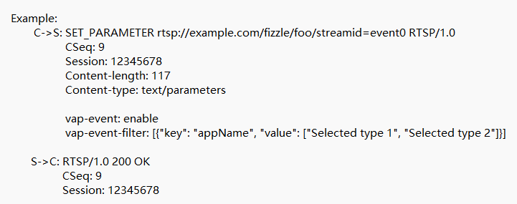

The event will be delivered to the client only when it matches all specified Filter Items.
If vap-event is set to enable and vap-event-filter is either not provided or is an empty list, all events will be delivered to the client.

Field Name | Type | Allowed Values | Description
vap-event | String | enable, disable | enable or disable forward events
vap-event-filter | JSON Array | List(filter-item) | A string containing a JSON-formatted array, the format is List(filter-item)
vap-event-filter.filter-item.key | String | type  appName  classification | Fields that need to be matched in the event
vap-event-filter.filter-item.value | String | <Any> | A string containing a JSON-formatted array, e.g. [“value1”, “value2”]

      - RTSP Playback Command
Control playback using RTSP PLAY Command, with support for speed adjustment and seeking. The valid scale values are 0.25, 0.5, 1, 2, 4, and 8.

E.g. Seek to 100s and change playback speed to 4x with PLAY:
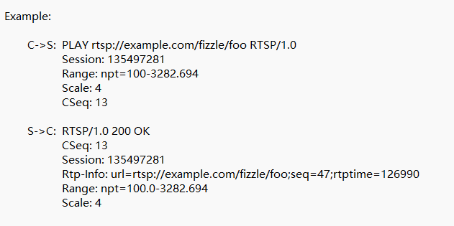

      - RTSP Channels
- As shown in the below SDP, there are 4 types of channels in RTSP stream:
- Video
- Audio
- Metadata
- Event
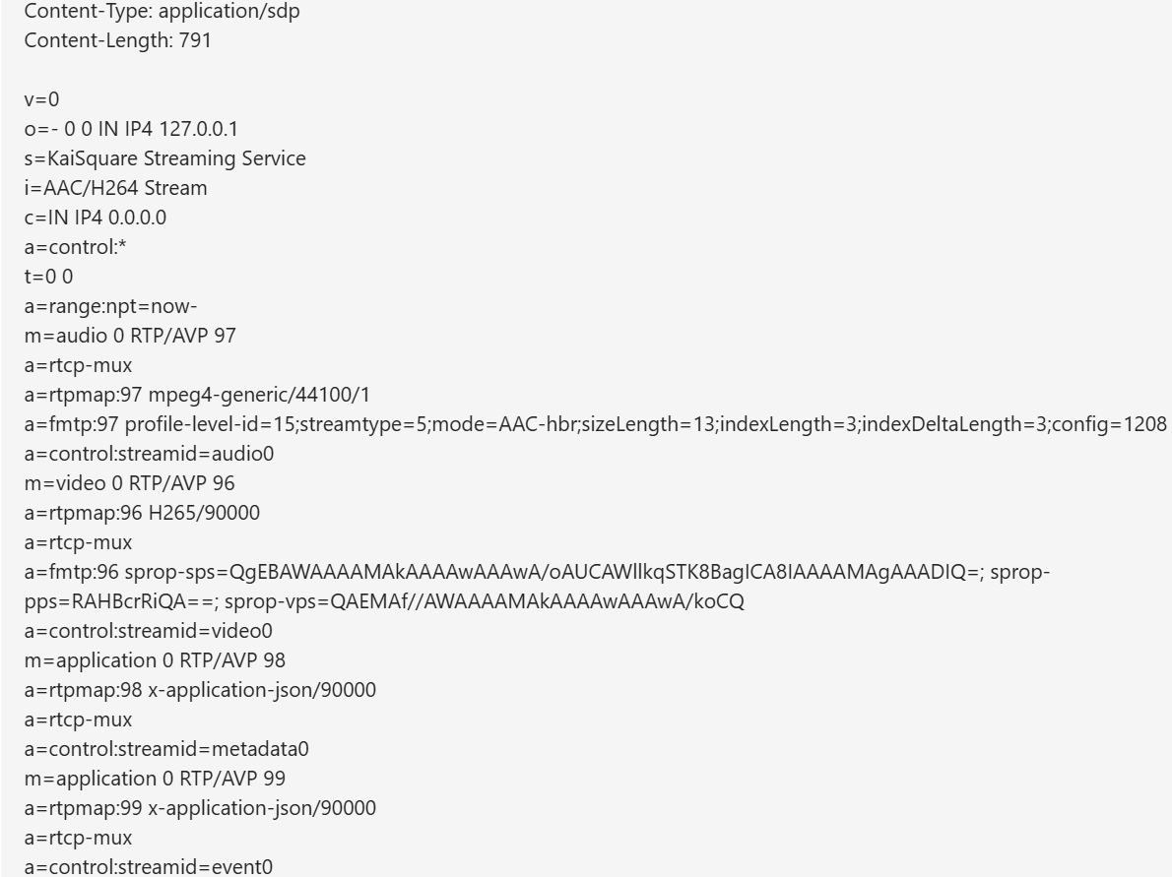
Figure 7 SDP Sample

      - Error Code In RTSP
Code | Message | Description
200 | OK | Request Success
201 | End of Stream | Playback is ended
400 | Bad Request | Request is invalid
404 | Not Found | Setup with error media
410 | Gone | Session was be ended
454 | Session Not found | Request with invalid session id
455 | Method Not Valid in This State | Send request in wrong order
461 | Unsupported Transport | Client setup with unsupported transport
501 | Not Implemented | The request not implemented
Table 6 RTSP Error Code

- When receiving error code 454, it means the session has expired, and it needs to call the RESTful API again to obtain a new session.
- When receiving error code 400, it indicates an request error (such as a camera stream failure), and C3 can attempt to perform the RTSP handshake again by using the existing RTSP URL.

      - UTC Timestamp in the RTP Header
- The following describes how to extract the frame's UTC timestamp from the RTP header.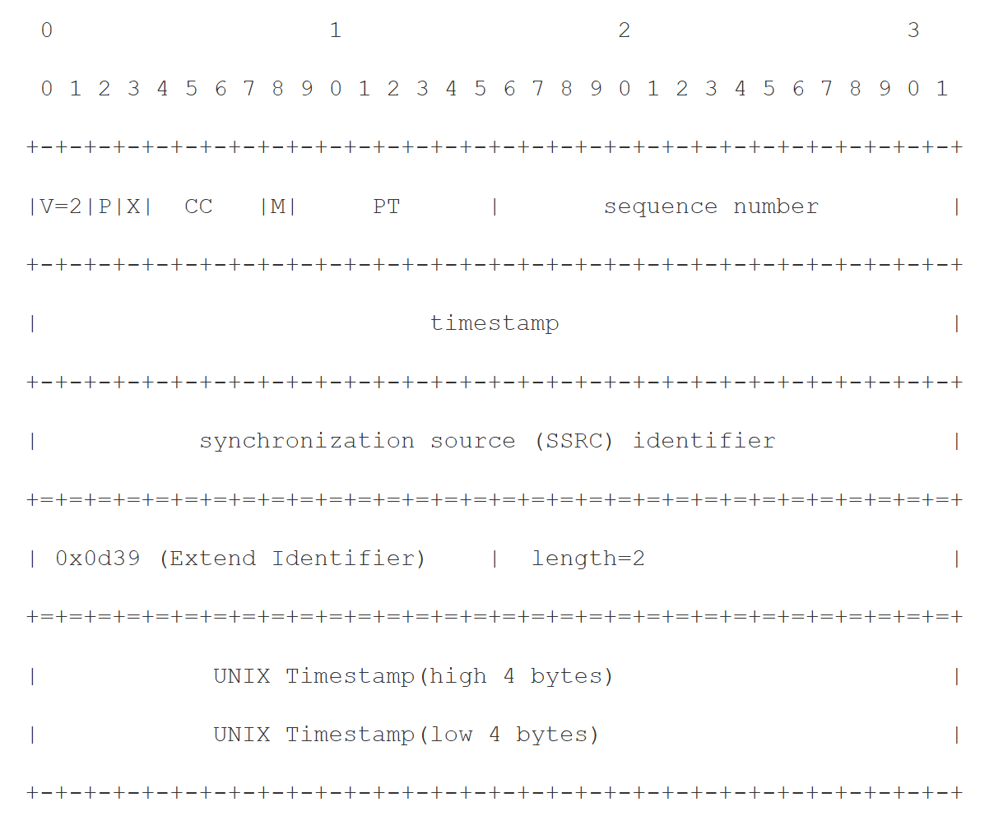

- The extension (X) bit indicates there’s header extension.
- The customized extension identifier is 0x0d39, 2 bytes in length.
- UNIX Timestamp (absolute UTC time from 1970-01-01 00:00:00.000) in the header extension is 8 bytes in big endian. The value of the length field should be 2 unit (1 unit = 4 bytes).

- Sample Javascript code to retrieve the UTC timestamp:
let bytes = new DataView(pkt.buffer, pkt.byteOffset, pkt.byteLength);
this.version = bytes.getUint8(0) >>> 6;
this.padding = (bytes.getUint8(0) & 0x20) >>> 5;
this.has_extension = (bytes.getUint8(0) & 0x10) >>> 4;
this.csrc = bytes.getUint8(0) & 0x0F;
this.marker = bytes.getUint8(1) >>> 7;
this.pt = bytes.getUint8(1) & 0x7F;
this.sequence = bytes.getUint16(2) ;
this.timestamp = bytes.getUint32(4);
this.ssrc = bytes.getUint32(8);
this.csrcs = [];
this.ts_cycle = false;
this.gopTimestamp = 0;

let pktIndex=12;
if (this.csrc>0) {
this.csrcs.push(bytes.getUint32(pktIndex));
pktIndex+=4;
}
if (this.has_extension==1) {
this.extension = bytes.getUint16(pktIndex);
this.ehl = bytes.getUint16(pktIndex+2);
pktIndex += 4;
// Check for UTC timestamp extension magic number
if (this.extension == 0x0d39) {
this.gopTimestamp = new Uint8Array([
bytes.getUint8(pktIndex),
bytes.getUint8(pktIndex+1),
bytes.getUint8(pktIndex+2),
bytes.getUint8(pktIndex+3),
bytes.getUint8(pktIndex+4),
bytes.getUint8(pktIndex+5),
bytes.getUint8(pktIndex+6),
bytes.getUint8(pktIndex+7)
]);
pktIndex += 8;
} else {
this.header_data = pkt.slice(pktIndex, this.ehl * 4);
pktIndex += (this.ehl * 4);
}
}

WebRTC Data Messages
      - Play

Field Name | Type | Allowed Values | Description
type | String(15) | PLAY | “PLAY”
seq | Uint32 | 1 - MAX_UINT32 | Unique ID per request, associated response will have the same seq.
body | BodyOfPlay Object |  | Specify the relevant parameters, it is used for playback, but optional for live view.

Data Object definition for BodyOfPlay.
Field Name | Type | Allowed Values | Description
seek | Int64 | MIN_INT64 - MAX_INT64 | Specify the time offset from the current position of the playback progress, in millisecond.
scale | Float | - 0.5  - 1  - 2  - 4  - 8  - 16 | Specify the scale factor for playback.

      - Pause
Field Name | Type | Allowed Values | Description
type | String(15) | PAUSE | “PAUSE”
seq | Unt32 | 1 – MAX_UINT32 | Unique ID per request, associated response will have the same seq.

      - KeepAlive
Field Name | Type | Allowed Values | Description
type | String(15) | KEEP_ALIVE | “KEEP_ALIVE”
seq | Unt32 | 1 – MAX_UINT32 | Unique ID per request, associated response will have the same seq.

      - Response
Field Name | Type | Allowed Values | Description
type | String(15) | RESPONSE | “RESPONSE”
seq | Uint32 | 1 – MAX_UINT32 | Unique ID per request, associated response will have the same seq.
code | Uint32 | 0 or 1 | If 0, it means request success, otherwise failed
message | String | - success  - failure | Error messages related to code:  0: success  1: failure

      - VA Event Message
Field Name | Type | Allowed Values | Description
type | String(15) | VA_EVENT | “VA_EVENT”
body | BodyOfVAEvent Object |  | Specify the VA Events.

Data Object definition for BodyOfVAEvent.
Field Name | Type | Allowed Values | Description
timestamp | Int64 | 0 – MAX_INT64 | Specify the UTC time of message sent
data | Array of Event Object | For Event Object, refer to VA Event IRS in Table 2.

      - Error Message
Field Name | Type | Allowed Values | Description
type | String(15) | EXCEPTION | “EXCEPTION”
code | Uint32 | Refer to Table WebRTC Error Code | Specify the error type
message | String(255) | Refer to Table WebRTC Error Code | Specify the error message

Code | Message | Description
201 | End of Stream | Playback is ended
400 | Bad Request | Request is invalid
404 | Not Found | Setup with error media
410 | Gone | Session was be ended
454 | Session Not found | Request with invalid session id
455 | Method Not Valid in This State | Send request in wrong order
501 | Not Implemented | The request not implemented
Table 7 WebRTC Error Code

- When receiving error code 454, it means the session has expired, and it needs to call the RESTful API again to obtain a new session.
- When receiving error code 400, it indicates an request error (such as a camera stream failure), and C3 needs to call the RESTful API again to obtain a new session.

